**IT Technology**

**Special Subject 2**



Lillebaelt Academy of

Professional Higher Education

Author:

Milan Kristof Vince:

mila1025@edu.eal.dk

October, 11, 2017

The following guide shows how to create telnet session between the vMX VCP-s on the ESXi and the physical machine.

**Step 1**

At navigation select the ESXi server and go to Configuration lab

Select Security Profile and click Properties

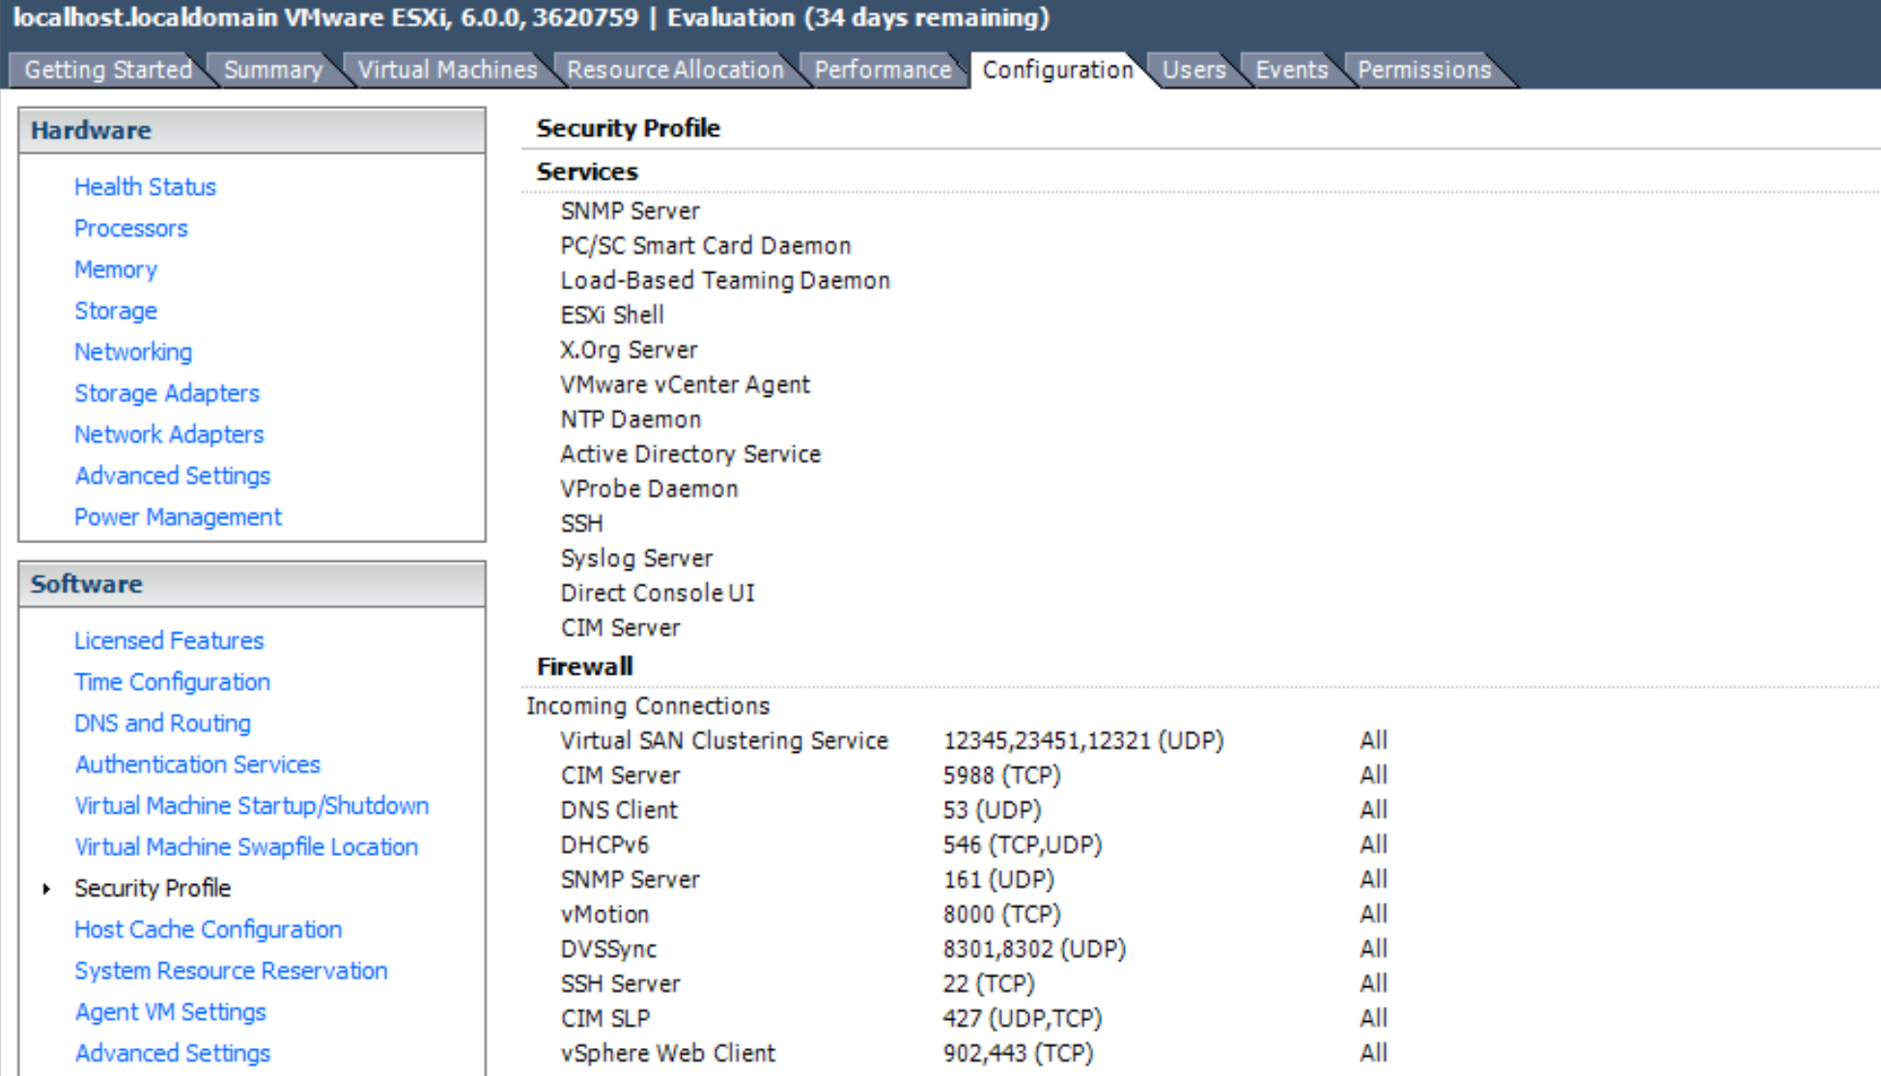

Select the **VM serial port connected over network** box and click **OK**.

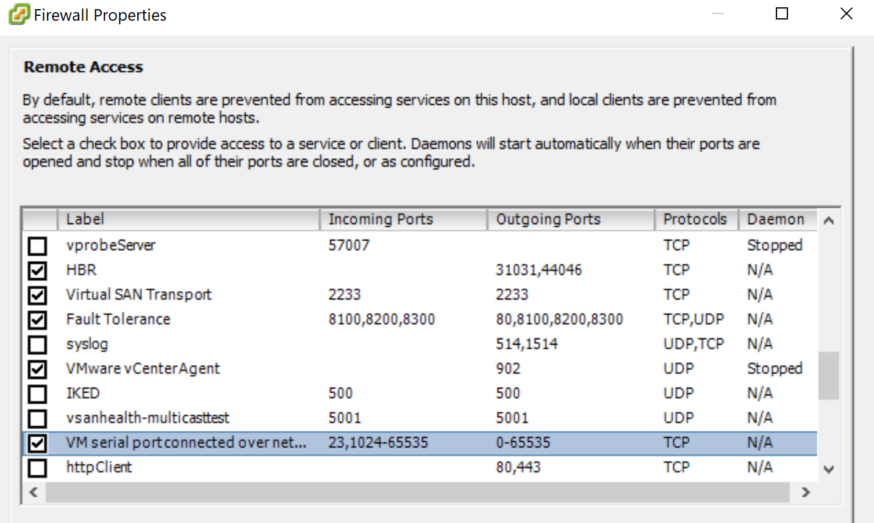

**Step 2**

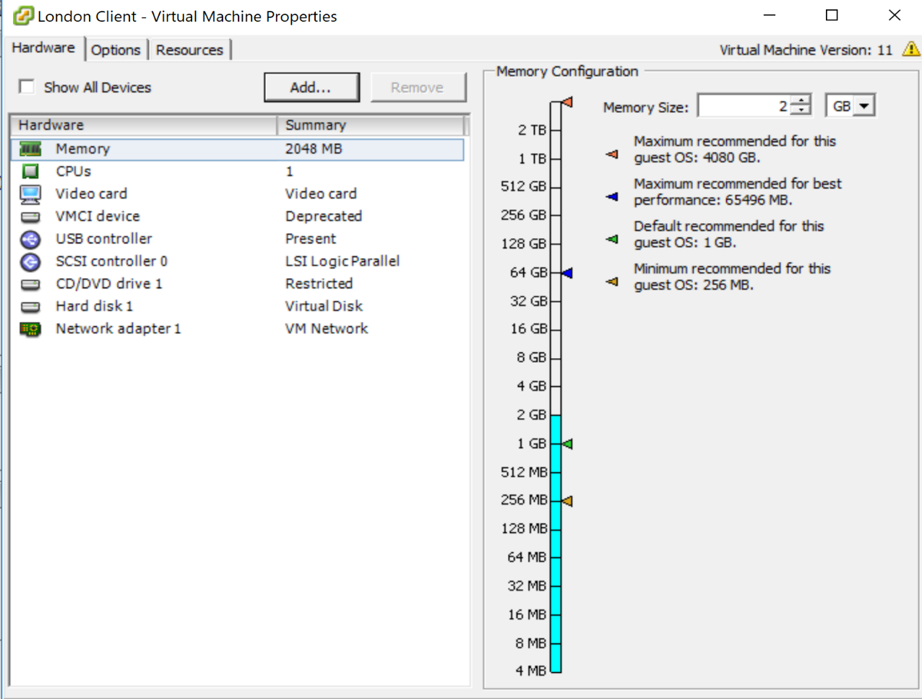At the Virtual machine click Edit Settings

Click Add

Select Serial Port

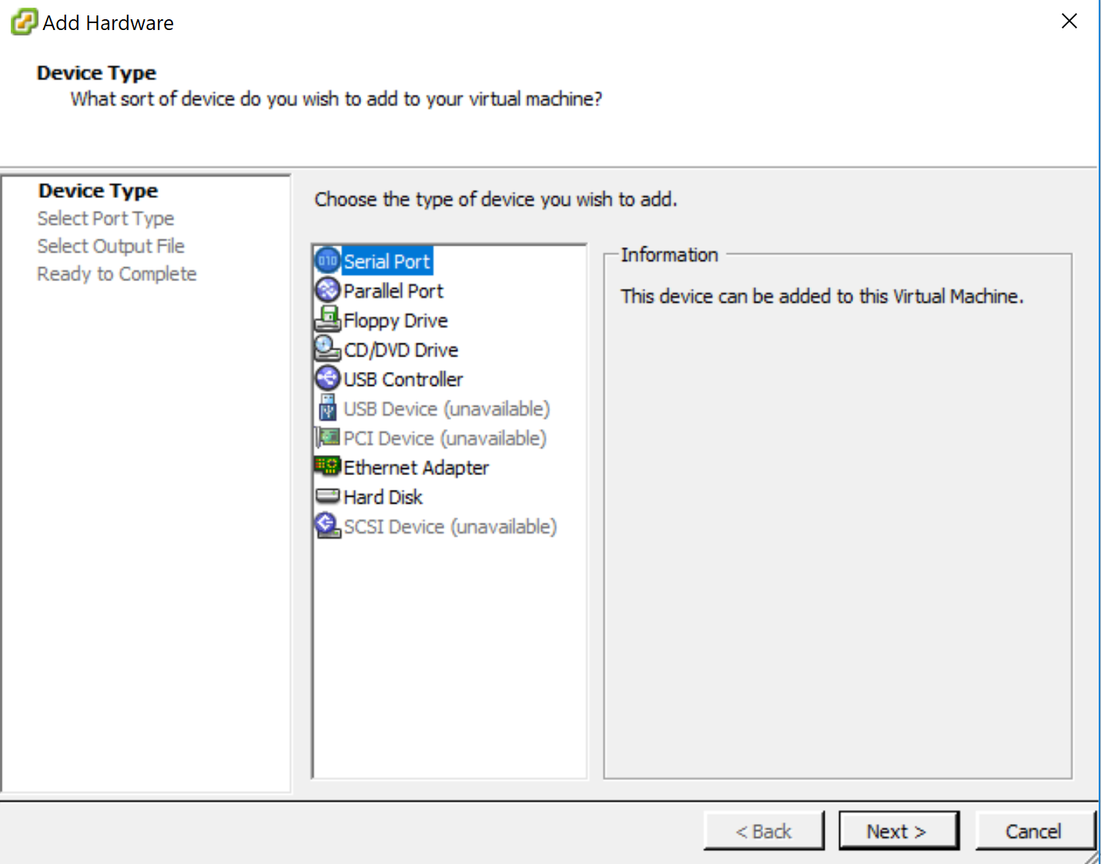

Select Connect via Network

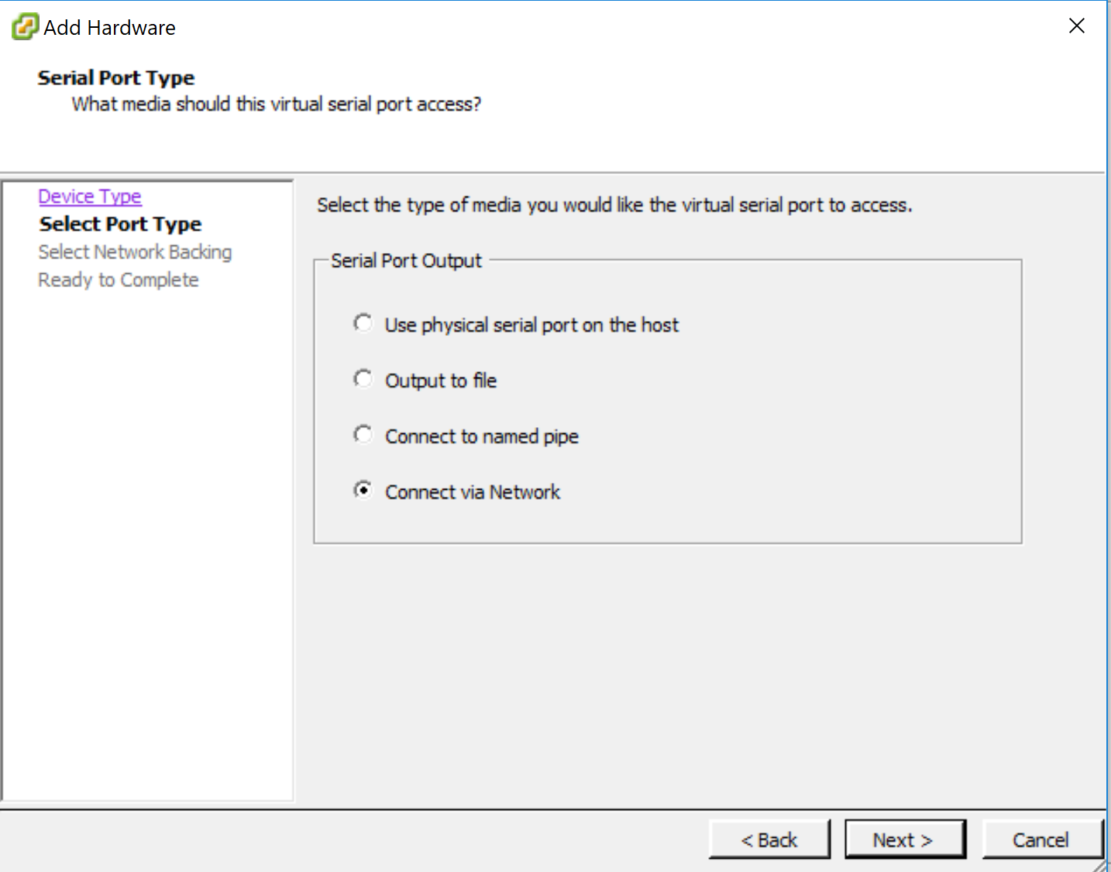

Then click on Server and type at Port URI:telnet://:*port-number* (<telnet://8601> for example)

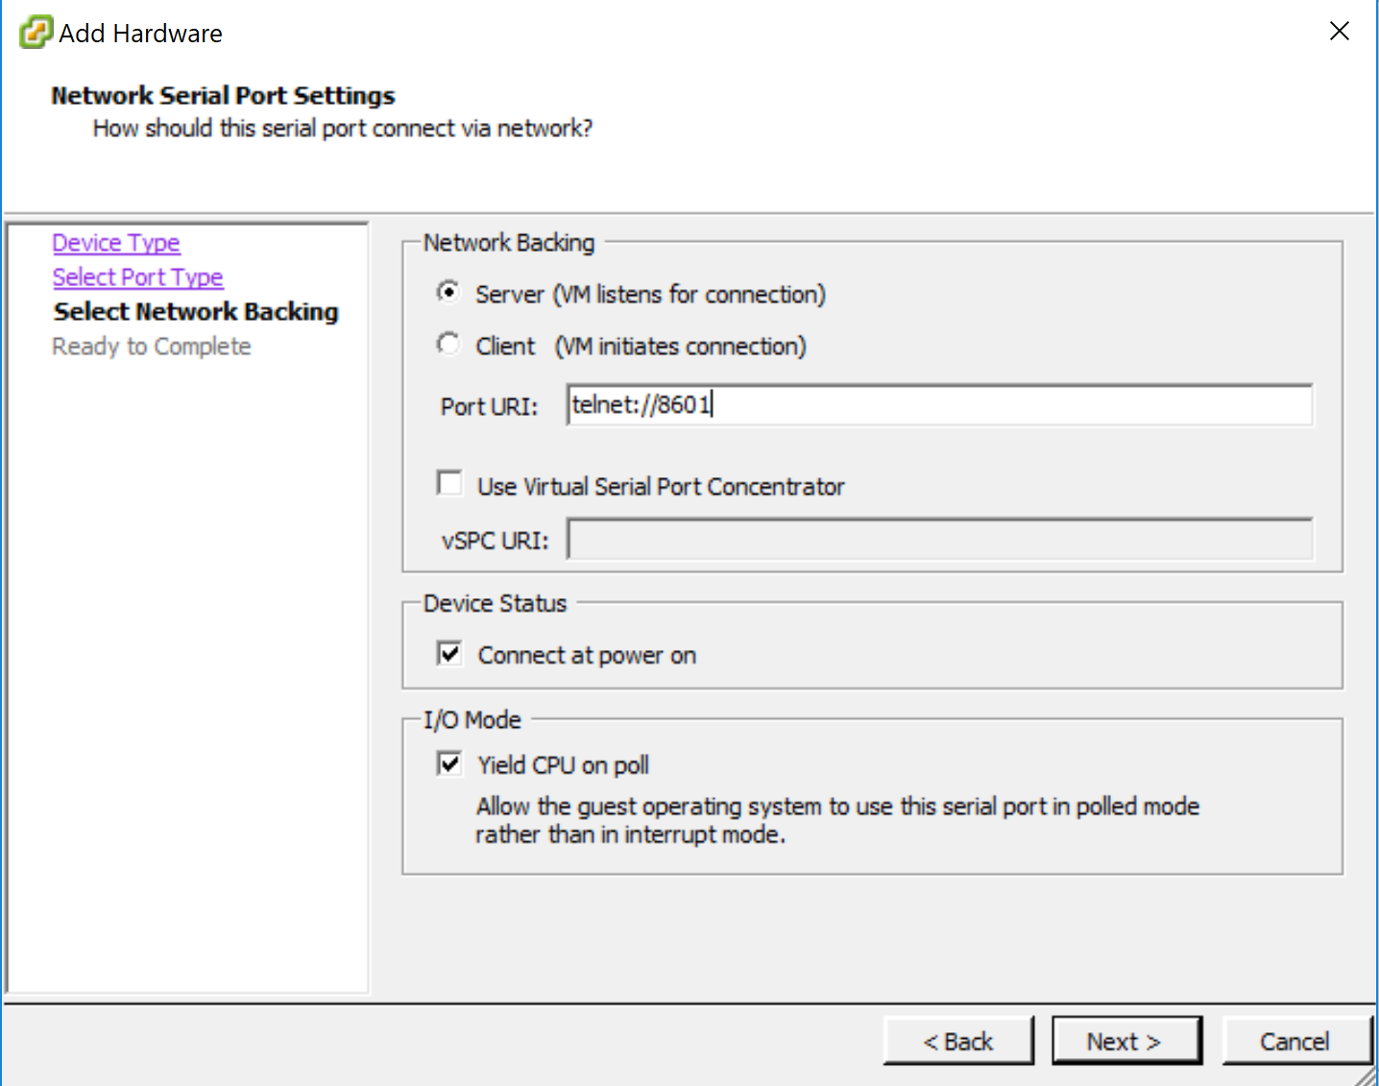

Click on Finish

Start the Virtual Machine

Open Command Prompt on your physical machine and type: telnet *ip-address port-number (*<telnet://8601>)

Then you should be able to connect to your VCP!